## Sprint 1

## Level Generation [RWMPC22-2]

**Link to JIRA:** https://jira.itcarlow.ie/browse/RWMPC22-2

**Description:** Random level generation that generates up or down in a 2d plane

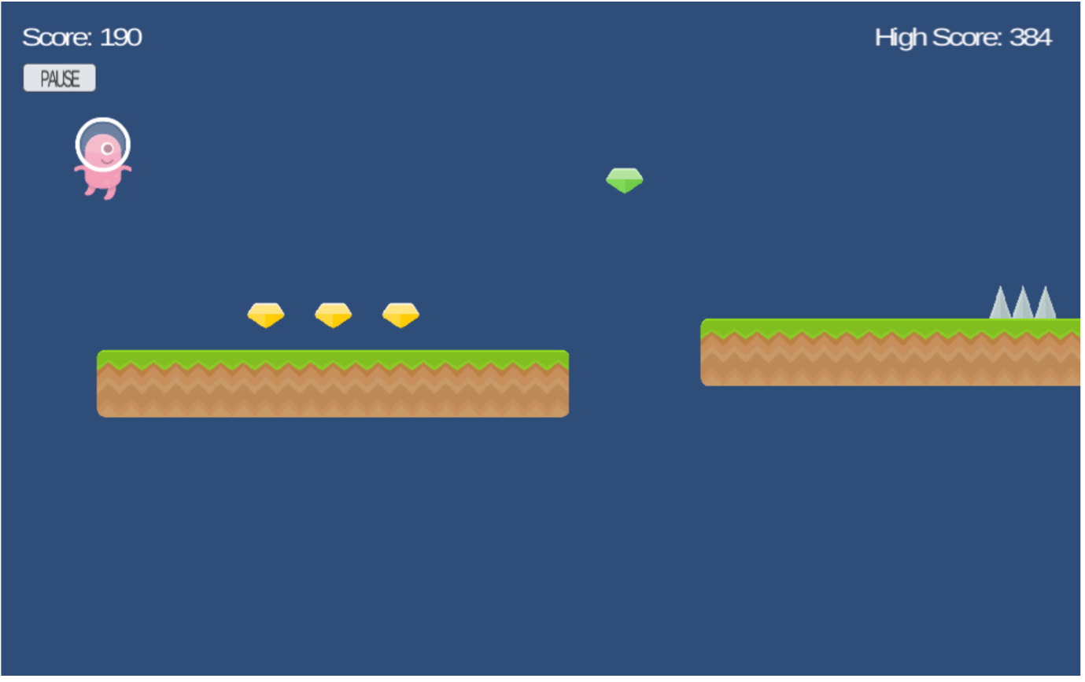

Figure 1: A Example of a random level generation

**Conditions of Satisfaction:**

1. adding chunks to the bottom of the screen. Chunks are square shapes
2. adding tiles onto the chunk at random amounts to simulate a randomly generated map
3. When the chunks are off the screen and aren't in use, destroy them to save resources
4. Add a hole obstacle by not drawing tiles above a few chunks in succession. Hole will be randomly generated
5. record what the top tile of each chunk is to potentially spawn an obstacle on top

**Link to the git commit:**

<https://github.com/AndrewGreenslade/RWS_P2_EndlessRunner/tree/WorldGeneration>

## Sprint 2

## Save and display score [RWMPC22-29]

**Link to JIRA:** <https://jira.itcarlow.ie/browse/RWMPC22-29>

**Description:** A high score that is displayed to the player at the end of the game

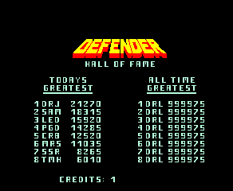

Figure 1: A Example of a high score screen.

**Conditions of Satisfaction:**

1. Add UI for Highscore and display it under the current score
2. Save players highest score for the session.
3. Display Highscore and the current run score after players death

**Link to the git commit:**

N/A

**Steps to Test:**

1. Save high score of any value,
2. Get all saved high scores,
3. Check saved high score against last in list